Authors’ Instructions for the Preparation
of The Full Paper
Introduction: This instruction file for Word users may be used as a template. Kindly send the final and checked Word and PDF files of your paper to the Conference Director.
The Structural Relationships between Foreign Language Speaking Anxiety, Perceived English Competence, English Learning Motivation, Willingness to Communicate, English Learning Engagement and Motivational Intensity in Hong Kong Secondary Students
Wai-Sum Chung
Department of Counselling of Psychology, Shue Yan University,
Hong Kong
E-mail: wilsonchung1@yahoo.com.hk
www.hksyu.edu
Man-Tak Leung
Department of Counselling of Psychology, Shue Yan University,
Hong Kong
E-mail:mtleung@hksyu.edu
www.hksyu.edu
Abstract. The abstract should summarize the contents of the paper and should contain at least 70 and at most 150 words. It should be set in 9-point font size and should be inset 1.0 cm from the right and left margins. There should be two blank (10-point) lines before and after the abstract. This document is in the required format.
Example:
This study recruited 305 participants (237 females and 68 males) to complete a survey consisting of 6 scales in examining the structural relationships among English learning motivation, foreign language speaking anxiety, perceived English competence, willingness to communicate, English learning engagement and motivational intensity in Hong Kong secondary students. First, English learning motivation (integrative, instrumental) negatively predicts foreign language speaking anxiety; which acts as a mediator between learning motivation and willingness to communicate (speak, read, write, listen). Second, perceived English competence, which is also a significant mediator between learning motivation and willingness to communicate (speak, read, write, listen), could be predicted positively by learning motivation. The present paper might be the first to investigate on the relationships between these constructs within the context of Hong Kong. It serves as a preliminary study to explore the casual relationships of HK secondary students’ psychological aspects in second language acquisition; while validating the instruments to be used in HK. On the pedagogical level, educators could understand the effects of students’ motivational orientations and eventually facilitate English learning through altering students’ affective factors.
Keywords: We would like to encourage you to list your keywords in this section.
Example:
Keywords: L2 acquisition; ESL/EFL; English learning motivation; Foreign language anxiety; Perceived competence; Willingness to communicate.
2 Paper Preparation
The printing area is 122 mm × 193 mm. The text should be justified to occupy the full line width, so that the right margin is not ragged, with words hyphenated as appropriate. Please fill pages so that the length of the text is no less than 180 mm, if possible.
Use 10-point type for the name(s) of the author(s) and 9-point type for the address(es) and the abstract. For the main text, please use 10-point type and single-line spacing. We recommend the use of Computer Modern Roman or Times. Italic type may be used to emphasize words in running text. Bold type and underlining should be avoided.
Papers not complying with the LNCS style will be reformatted. This can lead to an increase in the overall number of pages. We would therefore urge you not to squash your paper.
Headings. Headings should be capitalized (i.e., nouns, verbs, and all other words except articles, prepositions, and conjunctions should be set with an initial capital) and should, with the exception of the title, be aligned to the left. Words joined by a hyphen are subject to a special rule. If the first word can stand alone, the second word should be capitalized. The font sizes are given in Table 1.
Table 1. Font sizes of headings. Table captions should always be positioned above the tables.
Heading level | Example | Font size and style
Title (centered) | Lecture Notes … | 14 point, bold
1st-level heading | 1 Introduction | 12 point, bold
2nd-level heading | 2.1 Printing Area | 10 point, bold
3rd-level heading | Headings. Text follows … | 10 point, bold
4th-level heading | Remark. Text follows … | 10 point, italic

2.1 Tables
Example:

Table 3. Coefficient Alphas of the Main
Study
Scales | α
WhatsApp addiction scale
- Obsession | .730
- Neglect | .773
- Control disorder | .822
Difficulties in emotion regulation scale
- Non-accept | .837
- Goals | .837
- Impulse | .871
- Aware | .663
- Strategies | .861
- Clarity | .739
EPQ-RSC
- Extraversion | .841
- Neuroticism | .824
- Psychoticism | .607
Social connection of WhatsApp’s attitude scale | .810
Academic decrement scale | .846

2.2 Figures
Please check that the lines in line drawings are not interrupted and have a constant width. Grids and details within the figures must be clearly legible and may not be written one on top of the other. Line drawings should have a resolution of at least 800 dpi (preferably 1200 dpi). The lettering in figures should have a height of 2 mm (10-point type). Figures should be numbered and should have a caption which should always be positioned under the figures, in contrast to the caption belonging to a table, which should always appear above the table. Please center the captions between the margins and set them in 9-point type (Fig. 1 shows an example). The distance between text and figure should be about 8 mm, the distance between figure and caption about 6 mm.
To ensure that the reproduction of your illustrations is of a reasonable quality, we advise against the use of shading. The contrast should be as pronounced as possible.
If screenshots are necessary, please make sure that you are happy with the print quality before you send the files.
Example:
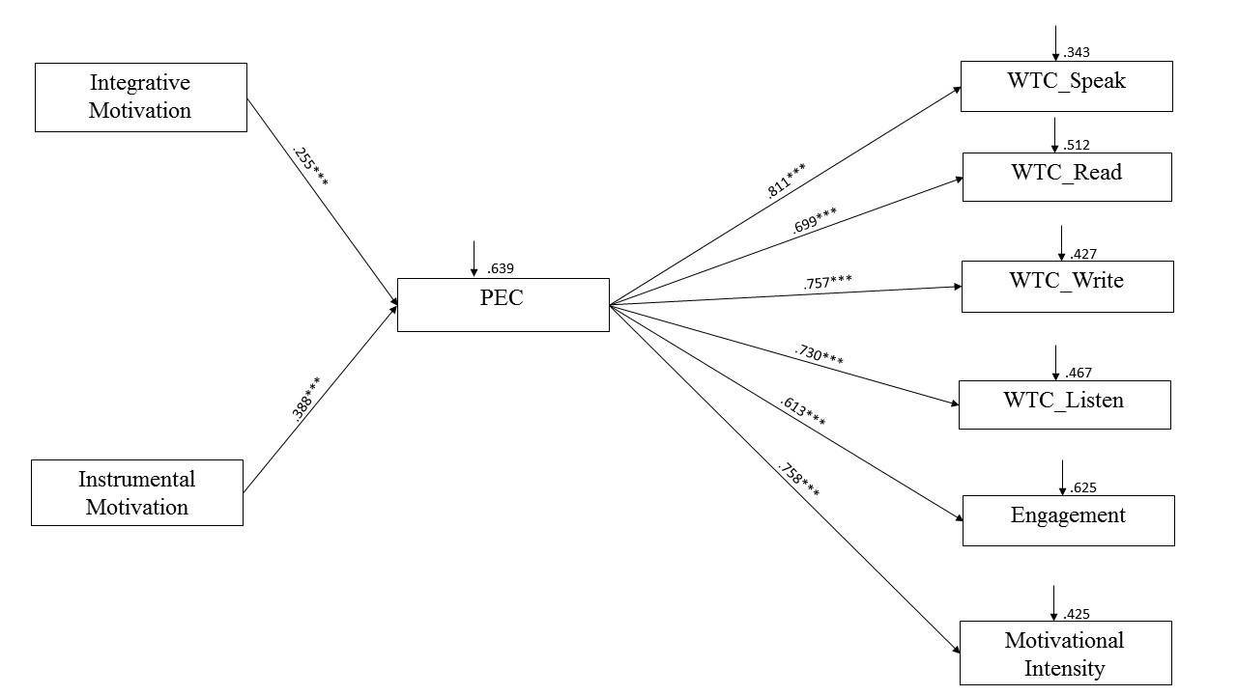
Fig. 1. The path diagram showing the predictive power of English Learning Motivation, Foreign Language Speaking Anxiety, Willingness to Communicate, English Learning Engagement and Motivational Intensity. Note: FLSA = foreign language speaking anxiety; WTC_Speak = willingness to speak; WTC_Read = willingness to read; WTC_Write = willingness to write; WTC_Listen = willingness to listen; Engagement = English learning engagement; *p<.05, **p<.01, ***p< .001.
2.3 Formulas
Displayed equations or formulas are centered and set on a separate line (with an extra line or halfline space above and below). Displayed expressions should be numbered for reference. The numbers should be consecutive within each section or within the contribution, with numbers enclosed in parentheses and set on the right margin.
a + b = c . | (1)

Equations should be punctuated in the same way as ordinary text but with a small space before the end punctuation mark.
2.4 Footnotes
The superscript numeral used to refer to a footnote appears in the text either directly after the word to be discussed or – in relation to a phrase or a sentence – following the punctuation mark (comma, semicolon, or period). Footnotes should appear at the bottom of the normal text area, with a line of about 5cm set immediately above them.

2.5 Citations
For citations in the text please strictly adhere to the convention set by APA.
2.6 Page Numbering and Running Heads
There is no need to include page numbers. If your paper title is too long to serve as a running head, it will be shortened. Your suggestion as to how to shorten it would be most welcome.
3 The References Section
References that don’t adhere to APA style will be reformatted. You should therefore check your references thoroughly before submission. The reference section must be complete.
References
- Kubery, R., Lavin, M., & Barrows, J. (2001). Internet use and collegiate academic performance decrements: Early findings. Journal of communication, 51(2), 366.
- Ledbetter, A. M. (2009). Measuring online communication attitude: Instrument development and validation. Communication Monographs, 76(4), 463-486.
- Eysenck, H. J., et al. (1996). Manual of the Eysenck Personality Scales (EPS Adult). London: Hodder & Stoughton Publishers.
- Eysenck, H.Y., & Eysenck, S.B.G. (1964). Manual of the Eysenck Personality Inventory. San Diego: Educational and Industrial Testing Services.

The footnote numeral is set flush left and the text follows with the usual word spacing.

